**Swetha Shree Byllahali Ananthaswamy**

**Information Technology Management**

**IFT-598 Middleware Prog & Database Sec**

**Professor: Dinesh Sthapit**

**Due Date: 09/10/2022**

**Module 2 Assignment: JavaScript language**

//function greetTheStudent(studentName){

   // return `Hello there  ${studentName}`

//}

//const greetTheStudent = function (studentName){

  //  return `Hello there  ${studentName}`

//}

//const greetTheStudent =  (studentName) =>{

  //  return `Hello there  ${studentName}`

//}

//const greetTheStudent =  (studentName) => `Hello there  ${studentName}`

const greetTheStudent =  studentName => `Hello there  ${studentName}`

// const fullName = function(lastName ,middleName ,firstName) {

//   return `${lastName} , ${middleName} ,${firstName}`

// }

  // const fullName = (lastName ,middleName ,firstName) => {

  //   return `${lastName} , ${middleName} ,${firstName}`

  // }

  const fullName = (lastName ,middleName ,firstName) => `${lastName} , ${middleName} ,${firstName}`

 const fullname = fullName('Rose','R','Mary')

console.log(fullname)

// const student ='Mary Jane'

// const greet = greetTheStudent(student)

// console.log(greet)

//console.log(message +' '+ studentName)

//console.log(message +' '+ studentName2)

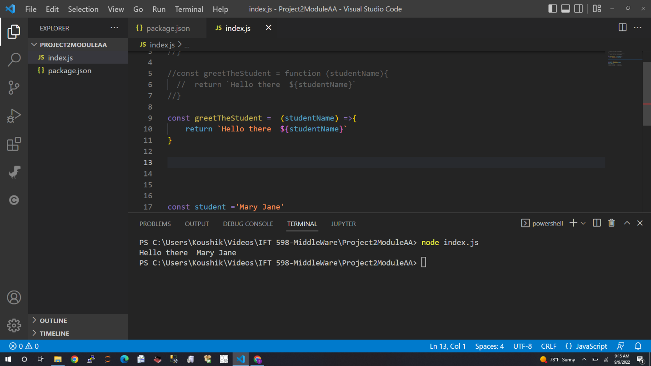

var age = 10

var salary = 15.00

// console.log(`variable type of age is ${typeof age}`);

// console.log(`variable type of salary is ${typeof salary}`);

// var name ='John Smith'

// console.log(`variable type of name is is ${typeof name}` );

const displayGreeting = function (name ,year) {

    console.log(`Happy new Year ${year} ${name}`);

}

// console.log(`variable type of displayGreeting is is ${typeof displayGreeting}` );

const displayGreetingWithEmoji = function (name ,year){

    console.log(`:-) :-) Happy new Year ${year} ${name} :-) :-)`);

}

const greet = function(name, year ,func){

    func(name,year)

}

greet('Sam',2022 , displayGreetingWithEmoji)

greet('Jane', 2022 ,displayGreeting)

var students = ['John' ,'Sammy','Jaime','Mike','Jane']

var grades =[90,99,89,100,80]

var studentInfo =[

                {

                    'name':'John',

                    'grade':90

                },

                {

                    'name':'Sammy',

                    'grade':99

                },

                {

                    'name':'Jaime',

                    'grade':89

                },

                {

                    'name':'Mike',

                    'grade':100

                },

                {

                    'name':'Jane',

                    'grade':80

                },

             ];

// console.log(students[0]);

// console.log(students[2]);

// console.log(students.length);

// console.log(grades[0]);

// console.log(grades[2]);

// console.log(grades.length);

// console.log(grades.length);

// console.log(grades[grades.length - 1]);

// console.log(grades[grades.length - 2]);

var students =[]

var student = {

    names:'Joan Smith',

    birthYear:2002,

    course:'IFT 458',

    grade:90,

    active:true,

    age: function(){

        if(this.active){

            return 2022 - this.birthYear

        }else{

            return 0

        }

    }

}

var student2 = {

    names:'Andy Moore',

    birthYear:2000,

    course:'IFT 458',

    grade:100,

    active: false,

    age: function(){// arrow function cannot access this reference

        if(this.active){

            return 2022 - this.birthYear

        }else{

            return 0

        }

    }

}

students.push(student)

students.push(student2)

console.log(students);

students.forEach((items)=> console.log(items.age()))

// console.log(student['names']);

// console.log(student.names);

// console.log(student2.age());

// console.log(student.age());

